

AHMAD NUR CAHYADI

190511094 / R3

1. 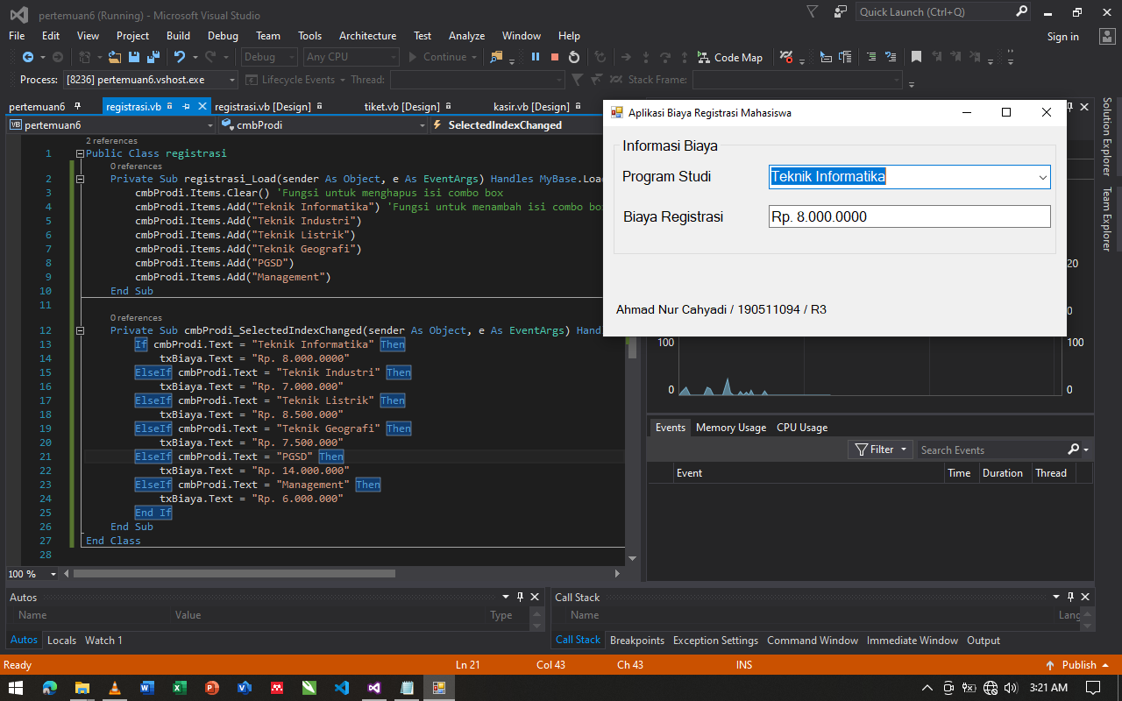Aplikasi Menentukan Biaya Registrasi Mahasiswa

Source Code nya :

Public Class registrasi

Private Sub registrasi_Load(sender As Object, e As EventArgs) Handles MyBase.Load

cmbProdi.Items.Clear() 'Fungsi untuk menghapus isi combo box

cmbProdi.Items.Add("Teknik Informatika") 'Fungsi untuk menambah isi combo box

cmbProdi.Items.Add("Teknik Industri")

cmbProdi.Items.Add("Teknik Listrik")

cmbProdi.Items.Add("Teknik Geografi")

cmbProdi.Items.Add("PGSD")

cmbProdi.Items.Add("Management")

End Sub

Private Sub cmbProdi_SelectedIndexChanged(sender As Object, e As EventArgs) Handles cmbProdi.SelectedIndexChanged

If cmbProdi.Text = "Teknik Informatika" Then

txBiaya.Text = "Rp. 8.000.0000"

ElseIf cmbProdi.Text = "Teknik Industri" Then

txBiaya.Text = "Rp. 7.000.000"

ElseIf cmbProdi.Text = "Teknik Listrik" Then

txBiaya.Text = "Rp. 8.500.000"

ElseIf cmbProdi.Text = "Teknik Geografi" Then

txBiaya.Text = "Rp. 7.500.000"

ElseIf cmbProdi.Text = "PGSD" Then

txBiaya.Text = "Rp. 14.000.000"

ElseIf cmbProdi.Text = "Management" Then

txBiaya.Text = "Rp. 6.000.000"

End If

End Sub

End Class

1. 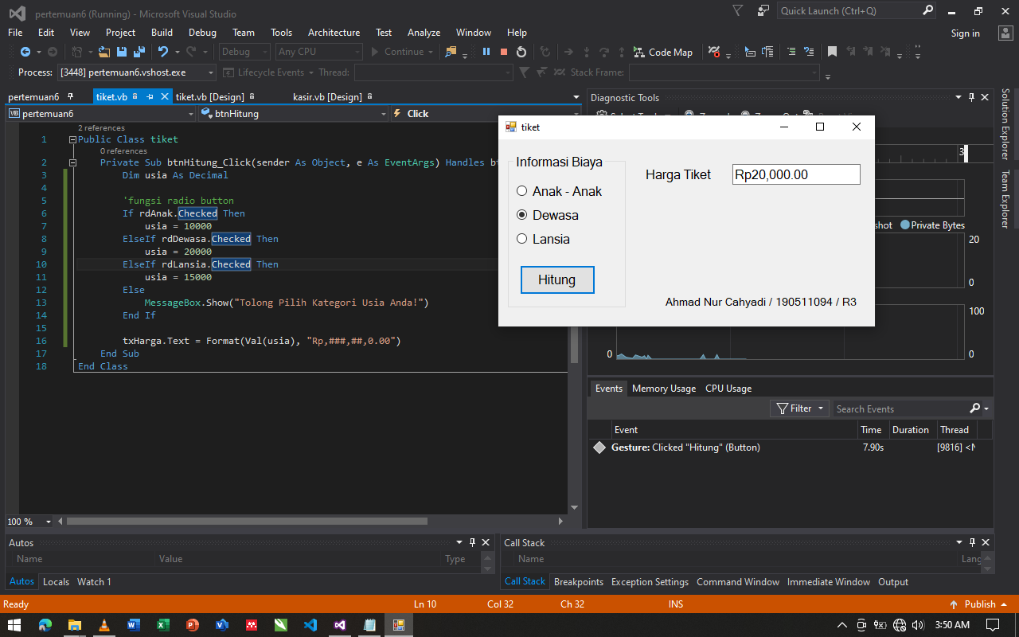Aplikasi Menentukan Harga Tiket

Source Code nya :

Public Class tiket

Private Sub btnHitung_Click(sender As Object, e As EventArgs) Handles btnHitung.Click

Dim usia As Decimal

'fungsi radio button

If rdAnak.Checked Then

usia = 10000

ElseIf rdDewasa.Checked Then

usia = 20000

ElseIf rdLansia.Checked Then

usia = 15000

Else

MessageBox.Show("Tolong Pilih Kategori Usia Anda!")

End If

txHarga.Text = Format(Val(usia), "Rp,###,##,0.00")

End Sub

End Class

1. Aplikasi Total Biaya Pembelian

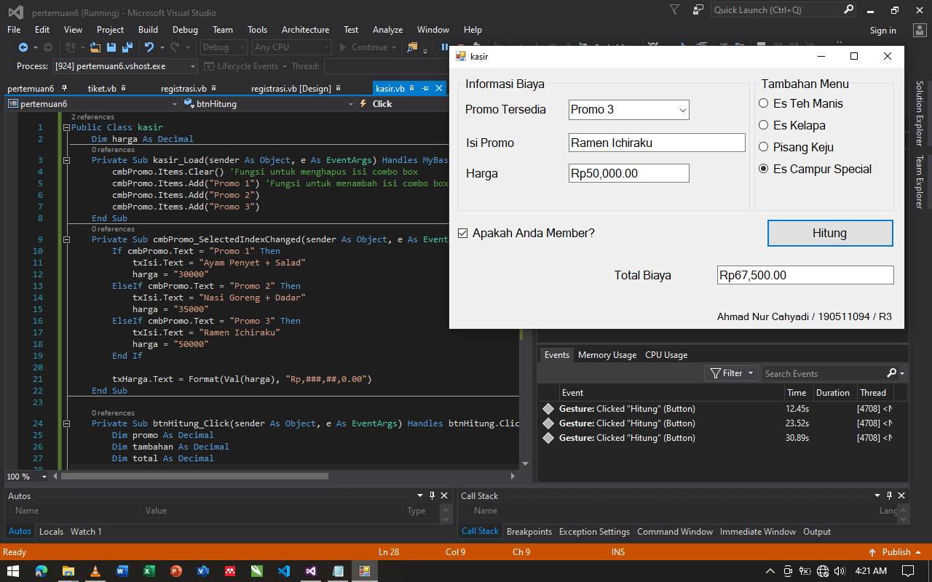

Source Code nya :

Public Class kasir

Dim harga As Decimal

Private Sub kasir_Load(sender As Object, e As EventArgs) Handles MyBase.Load

cmbPromo.Items.Clear() 'Fungsi untuk menghapus isi combo box

cmbPromo.Items.Add("Promo 1") 'Fungsi untuk menambah isi combo box

cmbPromo.Items.Add("Promo 2")

cmbPromo.Items.Add("Promo 3")

End Sub

Private Sub cmbPromo_SelectedIndexChanged(sender As Object, e As EventArgs) Handles cmbPromo.SelectedIndexChanged

If cmbPromo.Text = "Promo 1" Then

txIsi.Text = "Ayam Penyet + Salad"

harga = "30000"

ElseIf cmbPromo.Text = "Promo 2" Then

txIsi.Text = "Nasi Goreng + Dadar"

harga = "35000"

ElseIf cmbPromo.Text = "Promo 3" Then

txIsi.Text = "Ramen Ichiraku"

harga = "50000"

End If

txHarga.Text = Format(Val(harga), "Rp,###,##,0.00")

End Sub

Private Sub btnHitung_Click(sender As Object, e As EventArgs) Handles btnHitung.Click

Dim promo As Decimal

Dim tambahan As Decimal

Dim total As Decimal

promo = harga

'fungsi radio button

If rdMenu1.Checked Then

tambahan = 10000

ElseIf rdMenu2.Checked Then

tambahan = 20000

ElseIf rdMenu3.Checked Then

tambahan = 15000

ElseIf rdMenu4.Checked Then

tambahan = 25000

End If

total = promo + tambahan

If cbMember.Checked = True Then

total = (promo + tambahan) - (0.1 * (promo + tambahan))

Else

total = promo + tambahan

End If

txTotal.Text = Format(Val(total), "Rp,###,##,0.00")

End Sub

End Class